What is NgModule?
@NgModule is a decorator that defines an Angular module.
It tells Angular:
- which components belong to this module
- which other modules it uses (class x(add,mult,div ,sub(expose) class y (add,mult) , Class z(div) (main app)
- what should be exposed to other modules
- which component starts the app
Every Angular module is just a TypeScript class + @NgModule metadata

Structure of NgModule
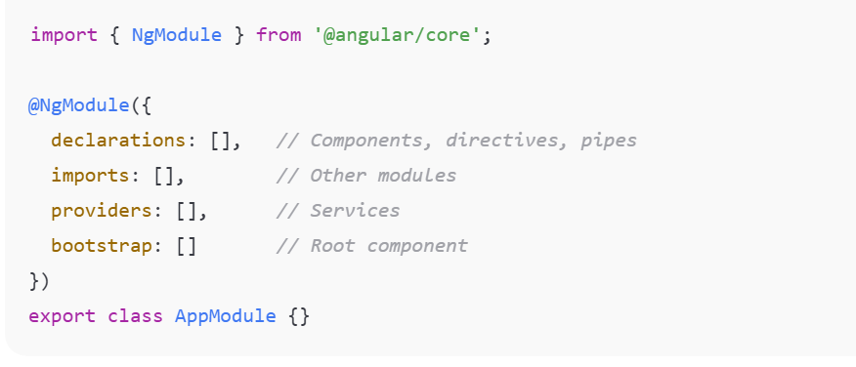

NgModule is used in Angular 2 and later versions including ,4 ,5,6 up to angular 16.
2016
2 to 16 version –ngmodule was mandatory
Angular 14+----Standalone Component
Angular 15+ ----stable
Angular 17+ ---Ngmodule is optional ,

NgModule need?
Organize features
Share components
Mange dependencies
Configure app startup

The @NgModule decorator accepts a metadata object with several important properties:
- declarations: An array of components, directives, and pipes that belong to this specific module. These classes are private to the module unless explicitly exported.
declarations: [AppComponent, HeaderComponent]
- imports: An array of other NgModule classes or standalone components, directives, and pipes whose exported components, directives, or pipes are needed by the component templates within this module. Examples include BrowserModule (in the root module) or CommonModule (in feature modules).
imports: [BrowserModule, FormsModule]
- exports: A subset of the declarations that should be visible and usable by the component templates of other NgModules that import this one. This is the module's public API.

- providers: An array of creators for services that the module contributes to the application's global collection of services via the dependency injection system.

Services available in this module.
providers: [UserService]

- bootstrap: The main application view, called the root component, which hosts all other app views. Only the root NgModule (usually AppModule) should set this property.
Root component to start app.
bootstrap: [AppComponent]

What is Root Module?
Root module is the main module that starts Angular application.
👉 It is loaded first
👉 It bootstraps the root component
👉 Only one root module exists
Default file: Ngmodule ---should not mention as standalone
If I mention standalone,mu application is having app.module.ts file
Will it considered or not? It will not consider or get neglect
app.module.ts

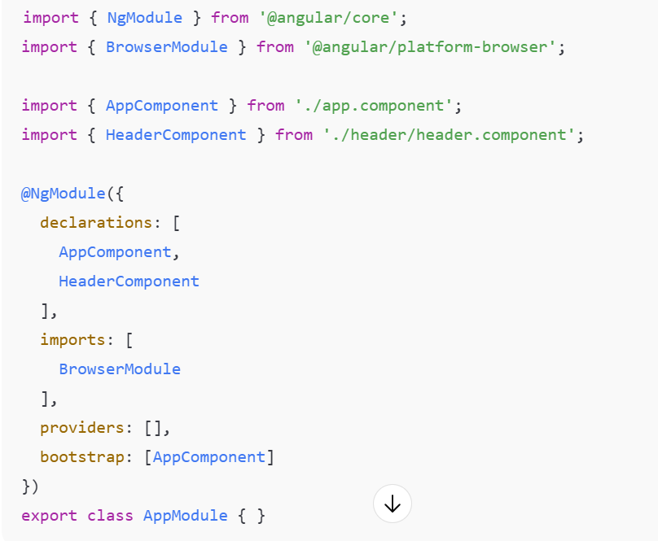

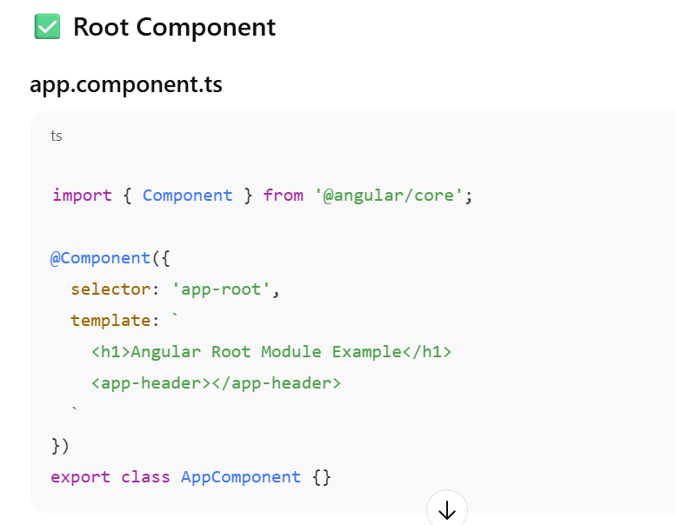
What is Feature Module?
Feature module is a module that contains specific functionality or feature of app.
Examples:
- User Module
- Admin Module
- Product Module
- Dashboard Module
👉 Helps in modular architecture
👉 Supports lazy loading
👉 Improves scalability

Create Feature Module
ng generate module user

✅ Feature Module Structure
user/
user.module.ts
user-list.component.ts
user-detail.component.ts

Shared Modules

What is Shared Module?
Shared module contains reusable components, directives, pipes used across multiple modules.
Examples:
- Header component
- Footer component
- Custom pipe
- Reusable buttons
- Common UI components
👉 Avoid duplicate code
👉 Used by many modules

What is Two-Way Data Binding in Angular
Two-way binding synchronizes:
- Component → View
- View → Component
It uses:
[(ngModel)]
This is called banana-in-a-box syntax.

Angular Directives
In Angular, a directive is a class that adds behavior or modifies the appearance of elements in the DOM (HTML).
There are 3 directive types in Angular overall:
- Structural Directives
- Attribute Directives
- Components (special directives with template)
Structural Directives
Purpose: Change the DOM layout by adding/removing elements.
They modify the structure of the HTML.
Key point
They use * syntax.
Common Structural Directives
- *ngIf → conditionally show/hide
- *ngFor → loop elements
- *ngSwitch → multiple conditions
Attribute Directives
Purpose: Change the appearance or behavior of an existing element.
They do NOT add/remove elements — they only modify them.
Common Attribute Directives
- ngClass → add/remove CSS classes
- ngStyle → apply inline styles
- ngModel → two-way binding

What is a Pipe in Angular
A pipe takes input data and returns transformed output. Hello-HELLO
Syntax
{{ value | pipeName:arg1:arg2 }}
Example:
{{ name | uppercase }}
{{ amount | currency:'INR' }}
{{ today | date:'dd/MM/yyyy' }}

Built-in Pipes Examples
Common Angular pipes:
- uppercase
- lowercase
- titlecase
- date
- currency
- percent
- slice
- json

<p>{{ 'angular pipes' | titlecase }}</p>
<p>{{ 1500 | currency:'INR' }}</p>
<p>{{ today | date:'fullDate' }}</p>

What is a Custom Pipe
A custom pipe = user-defined transformation.
Example use cases:
- Capitalize first letter
- Filter list
- Mask mobile number
- Format name

